Final Exam (CSCI6339, Fall 2020)

Due 11:59pm Monday Dec 7, 2020

Instruction: Dr. Bin Fu

Name: Ulvi Bajarani ID Number: 20539914

Please submit exam in MS word format.

1. a) Design an automata to accept 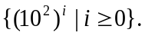
b) Prove that the language 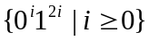is not regular.

Answer 1:

a) The possible solution (Reminder that in the case i=0, the input is the empty string):
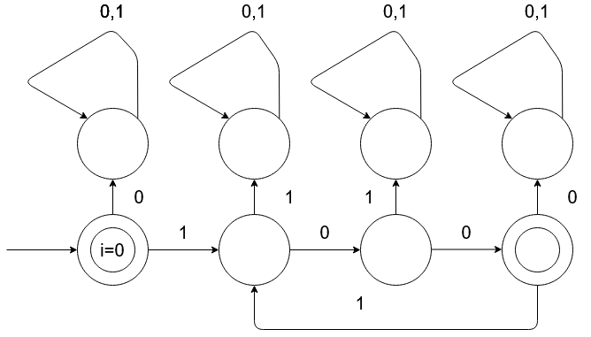
b) To prove if the language is not regular, we can use the pumping lemma. Let’s put p=6. In this case, x=0², y=1², and z=1² such that S=xyz, |S|=|xyz|=6≥p, |y|=2>0, |xy|=4≤p. As it might be seen, the total number of 0s are equal to the half of the total number of 1s. Let’s transform it to xyyz.
As we might see, the half of total number of 1s are higher than the total number of 0s, so we get the contradiction. It means that the language L={0^{i}1^{2i} , i≥0} is not regular.
2. Let L be the set of undirected graphs. Prove that L is in NL.

Answer 2:

To prove that the set of undirected graphs is in NL, we can check each member of the set in the non-deterministic Turing machine. To do this, the graph and its vertexes might be selected non-deterministically. The vertexes might be numerated and all edges from each node might be checked. If the all edges of the node is already visited, the node is going to be marked. There are required things:

a) the position of the read-tape choosing the graph;
b) the counter to define the number of visited nodes. If it is higher than the total number of the nodes, return REJECT;
c) the counter to define the number of not visited nodes. If it is equal to 0 and b) equal to the total number of the nodes, return ACCEPT;
d) the edge to be checked;

The algorithm is quite simple:

1) Repeat:
Non-deterministically choose the graph that is not checked yet;
Enumerate all nodes;
Repeat:

a) Non-deterministically choose the node that is not visited;
b) Non-deterministically check the edges of the node that is not visited;
c) Increment the counter of visited nodes;
d) Decrement the counter of not visited nodes;
e) Check the counter of visited nodes. If it is higher than the total number of the nodes, return REJECT;
f) Check the counter of not-visited nodes. If it is equal to 0 and e) equal to the total number of nodes, return ACCEPT;

Until:
The counter to define the number of not visited nodes is equal to 0.
Mark the graph is either directed or undirected;

Until:
There is no graph without the check.
2) If there is a directed graph, return REJECT, otherwise, return ACCEPT.

We can store all values in the binary, since it is lower than the maximum number of nodes. The maximum space is used for each graph in this case might be

a) the counter to define the number of visited nodes. It is equal to or lower than n.
b) the counter to define the number of visited nodes. It is equal to or lower than n.
c) the edge is in the check for the directions. Since all edges might be checked at the same time, the maximum number is double to the total number of the nodes n, which is equal to 2*((n²-n)/2) = (n²-n), because each edge contains two numbers of the nodes.

So, the maximum space for each graph is O(logn)+O(logn)+O(logn²)=4O(logn)=O(logn). Total number of the space for the set with m graphs is equal to O(log^{m}n). It means that our non-deterministic Turing machine is in NL.

The additional way to record if the set is directed or undirected is to use the additional tape with a verifier. The algorithm works as follows:

1) cross each bit of the verifier if the proper set is undirected or set 0 if the graph is directed;
2) After checking if there is 0 in the verifier, return REJECT, otherwise, ACCEPT.
3. For a Turing machine M(.) with an input w, let M(w) be the output on the output tape if it stops in finite steps. Let L={(M1, M2, w)| M1 and M2 are Turing machines, w is an input, and M1(w ) is not equal to M2(w)}. Prove that L is undecidable by finding a reduction from 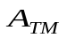 to it, where ={<M,w> |Turing machine M accepts w}.

Answer 3:

Assume that L is decidable. Then, there is the decider Turing machine R such that:

a) giving accept if L(M₁) ≠ L(M₂) in the input w;
b) giving reject if L(M₁) = L(M₂) in the input w;

Define Turing machines M₁ and M₂, where

a) M₁ accepts the input if A_{TM} returns accept;
b) M₂ accepts all inputs;

Then define the Turing machine S with input <M₁> such that

1) Runs R on <M₁, M₂>.
2) If R gives accept, then S also gives accept. If R gives reject, then S also gives reject.

If the languages are not equivalent, then M₁ doesn’t accept w. Else if the languages are equivalent, then M₁ accepts w. Since it is not possible to have a decider defining if the A_{TM} halts on w/or accepts the w, so we get the contradiction.

4. The subgraph-isomorphism problem takes two graphs G1 and G2 and asks whether G1 is isomorphic to a subgraph of G2. Show that
a) the subgraph-isomorphism problem is in NP; and
b) it is NP-complete by giving a polynomial time reduction from SAT problem to it.

Note: Two graphs G1=(V1, E1) and G2=(V2, E2) are isomorphic if there exists a one-one and onto function f( ) from V1 to V2 such that for every two nodes u and v in V1, (u,v) is in E1 if and only if (f(u), f(v)) is in E2. For examples, G1 is isomorphic to a subgraph with vertices {1,2,5,4} of G2 below.

G1 G2
1
2
3
4
1
5
2
4
3

Answer 4:

a) Let’s prove that the subgraph-isomorphism problem is in NP. To do this, we can check the provided subgraph G₂ . The verification process requires finding the correspondence between {u, v} edges in G₁ . and {f(u), f(v)} in G₂ . If the length of certificate is O(n), then verification process requires at most O(n²) steps (checking all pairs.), so the verification is polynomial and the subgraph-isomorphism problem is in NP;

b) Now, Let’s prove that there is a reduction from some NP problem to the subgraph-isomorphism problem in polynomial time. It is possible to this as CLIQUE≤_{P} subgraph-isomorphism:

Suppose there is the input <G, k> for CLIQUE, where G is the undirected graph and k is the number of clique. For the number of vertices of G₁ equal to n such that n≥k, we define G = G₁ , and G₂ as the graph with k vertices. The subgraph-isomorphism with < G₁ , G₂ > provides “accept” if and only if in the case where the clique with k vertices exists in the G. The copying of the G to G₁ requires O(n+m) time, while the creating the complete graph G₂ with k vertices requires O(n²) time. Since both of the time are polynomial, we have proved that the reduction CLIQUE≤_{P} subgraph-isomorphism occurs in polynomial time. Hence, subgraph-isomorphism problem is NP-complete.

